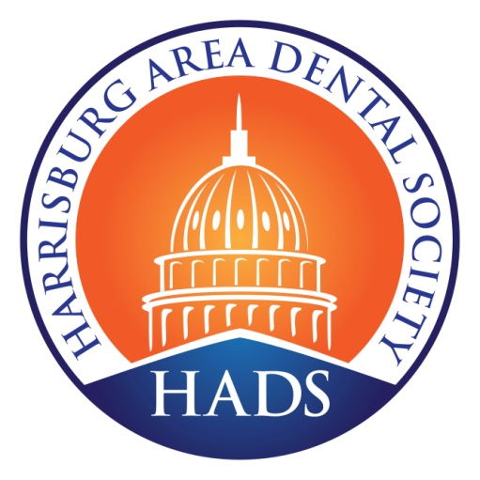
Koser Award
Friday December 10, 2021
Honoring: Dr. Eric Shirley
The Koser Award is given to a member of the Harrisburg Area Dental Society who most exemplifies the ideals set forth by the life of Dr. A.S. Koser. Dr. Koser was one of the founding members of HADS. He was highly involved in many other dental organizations including the PDA.
Dr. Koser also had a deep commitment to his fellow man and was actively involved in many organizations that benefited his local community. He was very active in his church. His patient list included State Senators and Representatives as well as people who are indigent and greatly needed dental care. He was most noted for being a great mentor and encourager of talented young people from our area who wished to enter the dental profession. This type of stewardship and community service is the hallmark of a Koser Award nominee.
Past Koser Award Recipients
1959 Dr. Albert Goho* 1979 Dr. Fred Keiper* 1998 Dr. Samuel Selcher
1960 Dr. Samuel Yoffe * 1984 Dr. Edwin Weaver * 2004 Dr. David Russell
1964 Dr. Curtis Sheely* 1985 Dr. Daniel Cohen 2006 Dr. William Spruill
1965 Dr. Clark J. Hollister * 1986 Dr. John Zeigler* 2007 Dr. Warren Silvers, II
1966 Dr. Will Everhard* 1987 Dr. Jack Beck* 2012 Dr. Harry Meyers
1967 Dr. Robert McEldowney* 1988 Dr. John Gilson* 2016 Dr. David Larson
1969 Dr. Bernard Grossman* 1989 Dr. Bruce Mathias* 2018 Dr. John Kiessling
Dr. Marcus Jaquette* 1990 Dr. John Bubeck*
1973 Dr. George Shopp* 1991 Dr. George Palmer*
1974 Dr. Alex McKechnie* 1992 Dr. William Walker
1975 Dr. Charles Ludwig * 1997 Dr. Sara Prioleau
* Deceased

Honoring Dr. Eric Shirley
Dr. Shirley is a graduate of the University Of Pittsburgh l for his undergraduate degree and the University of Pittsburgh of school of Dental Medicine class of 1991. After dental school Eric served three years in the US Navy and was recognized there with the Commanding Officer Award for Clinical Excellence. His service to organized dentistry began as a member of the Executive committee in 1996 when he began a three year term as treasurer. Eric was president of HADS in 2001 and has remained on the Executive Committee ever since and is currently chair of the Finance/ Investment Committee. He has served the Pennsylvania Dental Association first as a member of the Direct Reimbursement Task force, and then as a member of the Pennsylvania Dental Association Insurance Committee from 2009 to 2015. At the American Dental Association, Eric has served as a member of the ADA House of Delegates as an alternate delegate for two years, and on the Council on Members Insurance and Retirement Program for three years. Dr. Shirley has been a member of the Academy of General Dentistry since 1994, Hershey Area Study Club since 1996, and a director on the Delta Dental of Pennsylvania Board of directors for two years. His volunteer service has included: Harrisburg Smiles, Mission of Mercy at Christ’s Lutheran Church, Mom-N-Pa, and Donated Dental Service.
Congratulations on this well-deserved honor!

